**Month-to-date total**

The month to date aggregates data from the first day of the month, as shown in Figure 4.

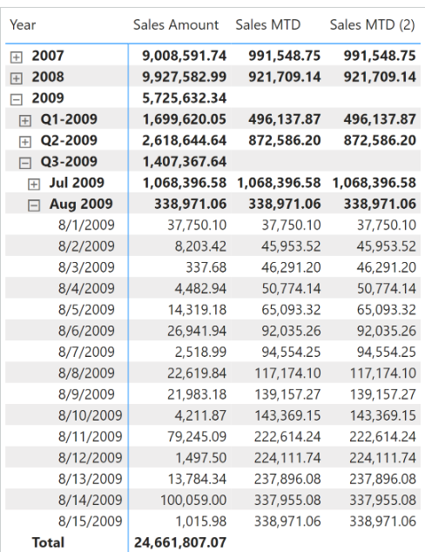

The month-to-date total of a measure is computed with the [**DATESMTD**](https://dax.guide/datesmtd/?aff=dax-patterns) function this way:

Sales MTD :=

IF (

    [ShowValueForDates],

    CALCULATE (

        [Sales Amount],

        DATESMTD ( 'Date'[Date] )

    )

)

The [**TOTALMTD**](https://dax.guide/totalmtd/?aff=dax-patterns) is a possible alternative to [**DATESMTD**](https://dax.guide/datesmtd/?aff=dax-patterns) :

Sales MTD (2) :=

IF (

    [ShowValueForDates],

    TOTALMTD (

        [Sales Amount],

        'Date'[Date]

    )

)